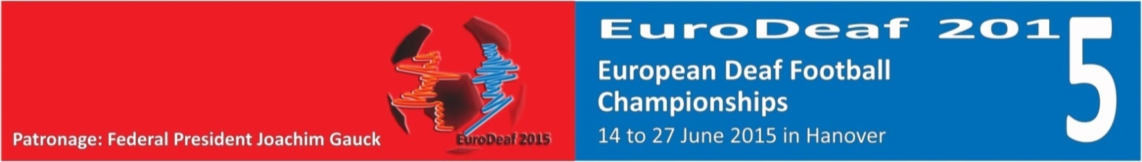

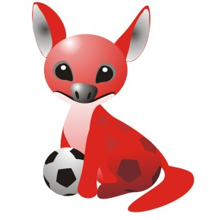
European Deaf Football Championships (men and women) 2015
www.eurodeaf2015.eu
A P P L I C A T I O N F O R M

Please send your application till the 30th March 2015 to Anne Köster a.koester@dg-sv.de.
the application form may be downloaded here: http://www.eurodeaf2015.eu/information.php?lang=de

personal data
surname, name |  | dare of birth
adress |  | postal code and residence
phone |  | mobile
e-mail |  | standard size
profession

possible term of work:
I may work for the whole term of the event – 13th to 28 June 2015
I may work |  | from till

local knowledge of Hanover
very good
some
none

Fußballkenntnisse
very good
some
none

foreign languages knowledge
sign language
foreign language – which one?
none

desired volunteer job, you may apply for more than one job
communication and team guide
in the stadium
for transport (already required on 12th June)
public relations
competition office

Do you have any experience in the work you are applying for? Have you ever done such work before? If so please let us know.

In April or May 2015 we will have a seminar and introduce you to your job during the EuroDeaf 2015 in der „Akademie des Sports in Hanover”.

^{place & date} |  | ^{signature}

!Thanks for your application!
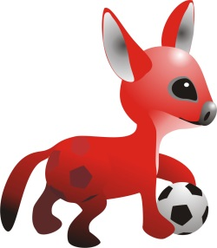
Deutscher Gehörlosen-Sportverband
Tenderweg 9
45141 Essen
0201 8141712
www.dg-sv.de

